Mauritius

## Respect for rule of law (ROL) data

The data set shows the data on the respect of the rule of law for the country.

## # A tibble: 19 x 5  
## country iso3c date ruleOfLaw ruleOfLawCategory4   
## <chr> <chr> <dbl> <dbl> <chr>   
## 1 Mauritius MUS 1996 0.896 ROL moderately respected  
## 2 Mauritius MUS 1998 1.05 ROL highly respected   
## 3 Mauritius MUS 2000 0.982 ROL moderately respected  
## 4 Mauritius MUS 2002 1.05 ROL highly respected   
## 5 Mauritius MUS 2003 1.08 ROL highly respected   
## 6 Mauritius MUS 2004 1.00 ROL highly respected   
## 7 Mauritius MUS 2005 1.03 ROL highly respected   
## 8 Mauritius MUS 2006 0.882 ROL moderately respected  
## 9 Mauritius MUS 2007 0.910 ROL moderately respected  
## 10 Mauritius MUS 2008 0.996 ROL moderately respected  
## 11 Mauritius MUS 2009 0.943 ROL moderately respected  
## 12 Mauritius MUS 2010 0.858 ROL moderately respected  
## 13 Mauritius MUS 2011 0.902 ROL moderately respected  
## 14 Mauritius MUS 2012 0.975 ROL moderately respected  
## 15 Mauritius MUS 2013 0.950 ROL moderately respected  
## 16 Mauritius MUS 2014 0.913 ROL moderately respected  
## 17 Mauritius MUS 2015 0.854 ROL moderately respected  
## 18 Mauritius MUS 2016 0.751 ROL moderately respected  
## 19 Mauritius MUS 2017 0.680 ROL moderately respected

## Respect for rule of law (ROL) trend

The plot shows the trend of the respect for the rule of law for the country.

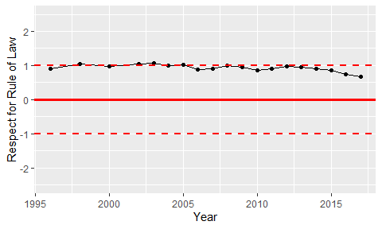

Trend of the Respect for the Rule of Law